Name ______________________________ Homework May 1-5
Put your initials by each night that your child practiced the following:
____Monday ____Tuesday ____Thursday
*Nightly Homework*
1. Read Start Right Reader page.
2. Count numbers 1-100.
3. Practice assigned Sight Word list in red reading folder.

Monday: Say each picture. Put them together and say the new word.
+ | + | +
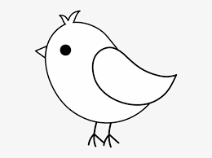+ | + | 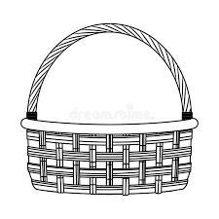+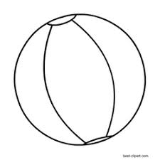

Color the pictures that end with the /j/ sound orange and the pictures that end with the /s/ sound blue.
badge | cage  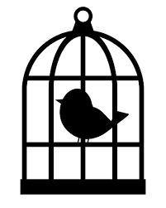 | face | mice  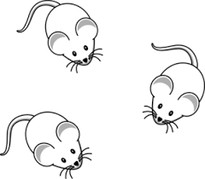
page  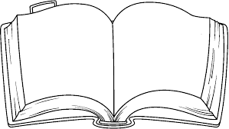 | race  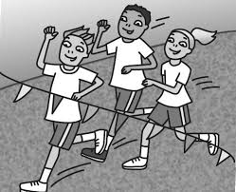 | dice  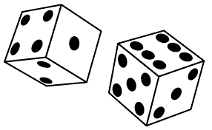 | stage  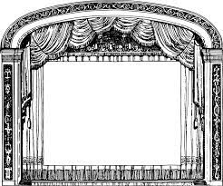

Tuesday: Write each spelling word three times.
rap | had | rub | cut | rot | pop | jig | zig | bed | set
____  ____ | ____  ____ | ____  ____ | ____  ____ | ____  ____ | ____  ____ | ____  ____ | ____  ____ | ____  ____ | ____  ____
____ | ____ | ____ | ____ | ____ | ____ | ____ | ____ | ____ | ____
Thursday: Add a beginning sound to finish the word.
___age | ___ace | ___ice | ___age

Color the picture and label it. Write 2 sentences about it.

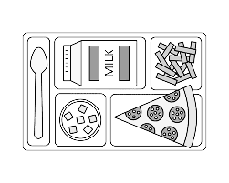

_____________________________________________________________

_____________________________________________________________

_____________________________________________________________

Words to Know

make time all into

Rice Race

Ace and Gem must pick rice for Mom.
“Gem, we can race. I can pick ten bags of rice stems in no time!” said Ace. The race takes them deep into the rice stems. They pick rice at a quick pace. The kids stop to rest. Ace wipes his face. “Gem? Where are we, Gem?” “Ace, our home is past that huge hill. We will make it back just fine,” Gem tells him. Ace and Gem race back home. “Just in time!” yells Mom. “Nice job!”

Talk about the story and answer the questions:
Who are the main characters? What are Ace and Gem racing to do? Where does the race take them? Why do the kids stop? Where is Ace and Gem’s home? What does Mom say to Ace and Gem?

